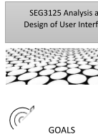

LAB 4 - Designing a website to demonstrate design principles

Design principles help us design websites that will make users productive. The purpose of this laboratory is to build a website for a service shop that will respect the design principles presented in Dr. Norman's book *Design of Everyday Things.* The design principles we’re going to focus on are visibility, feedback, affordance, mapping, constraints and consistency.

During this laboratory, you will need to:

* Learn a CSS framework, Bootstrap, to make website design easier with a more modern and standardized look.
* Develop a semi-static site (responding only in Bootstrap components) in which you pay close attention to design principles.



SUBMISSION DEADLINE

* Sunday, February 9, 2024, 11:59 p.m.



SUBMISSION METHOD

* In Brightspace, the lab 4 contains a link to your submission.
* *WARNING: Any code or even "little piece of code" you take from a website such as stack overflow or other should be accompanied by a comment that recognizes the source. You must, in your submission text, state "Code for X inspired by (html link)")*

1. Submit a pdf document consisting of the following:
   1. Group number
   2. Group members
   3. Each members contribution.
   4. Link to the Github repo.
   5. Snapshots of the website created



INSTRUCTIONS / TUTORIALS TO FOLLOW

We are continuing the exploration of HTML/CSS/JavaScript technologies that are mostly used for building websites. This week we will use a framework called Bootstrap. Next week we continue with JQuery, because Bootstrap and JQuery are often used together. In Lab 4, we will focus only on Bootstrap.

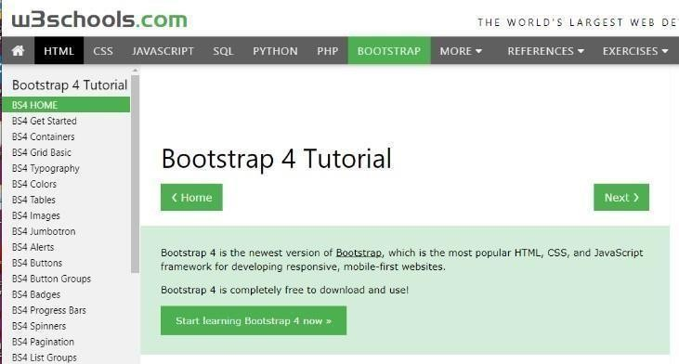You've seen so far that HTML/CSS is used to design your web page and that Javascript allows you to perform actions (modifying the DOM based on events).

Bootstrap is mainly to help with HTML writing, having already pre-encoded several styles into a CSS style sheet that you need to import into your HTML code, and having pre-programmed JavaScript scripts in a

script file that you also need to import into your HTML.

Bootstrap has already done some of the work for you... It offers standardized styles for colors, buttons, certain structural patterns, etc. All this to get a nicer website, with less effort. Now that you've worked with basic HTML/CSS/JS in the last 2 labs, you'll be able to better appreciate what Bootstrap has to offer.

I suggest you use, again, the w3schools.com site, to explore what is possible to do with [Bootstrap](https://www.w3schools.com/bootstrap4/default.asp)

1. You can also use the code I provide you (see Starting Point section) which contains several small bits of code and links to the appropriate sections of the tutorial on Bootstrap 4 in the w3schools site.



Design

In this lab, you must choose a service company from two options:

* 1. Hair Salon/ Barbershop
  2. Bicycle Repair Shop

What is common to these companies is that:

* There is a physical place (address) to go to.
* You can make an appointment for a service (e.g., haircut, brake repair)
* Several services are offered (e.g., long cut, short cut, tune-up, repair)

I strongly suggest you first try to make paper sketches of your website. You must think monochrome first, even if later you want to include colors. Thus, the paper sketch is the best way to propose several quick ideas in monochrome.

Once you start programming, be sure to pay close attention to your color and font choices so that they reflect the image you want to project for your site. One of our themes this week is visual communication. Make sure you have a good visual communication.

Don't know where to start? Take inspiration from existing sites by seeing what you like and what you don't like about the *layout,* the colors, the fonts, the alignment of the text. Ask yourself if these sites offer good visibility and potential. Ask yourself what is the aesthetic coherence of the site and what creates this consistency. Is the text readable (look at the alignment)?

The sites below are just examples. <https://www.atelier-velo.com/>

[http://www.cycosport.c](https://www.atelier-velo.com/)[a/](http://www.cycosport.ca/)

[p://bikemobile.ca](http://bikemobile.ca/)/ <https://hairrepublic.ca/> [https://metcalfe-barber-shop.business.site/ c.ca/](https://metcalfe-barber-shop.business.site/)

[https://hairdynami](https://hairdynamic.ca/)



STARTING POINT

I provide a [code file t](https://github.com/carolinebarriere/carolinebarriere.github.io/tree/master/SEG3125-Module4-Service)hat uses Bootstrap components in a "mixed" way but shows the use of Bootstrap. You can see the rendering [here. I](https://carolinebarriere.github.io/SEG3125-Module4-Service/) suggest you browse this code in which you can find several comments and links to appropriate sections of the tutorials offered by the w3schools.

Don't forget that this is just a starting point, your site should reflect your design choices.



Programming

You must generate a web page to choose a service, a date, and provide your personal information to book that service. We will continue this site next week using jQuery to add payment information validation. But for this week your focus is ONLY on the design of your page, on design principles and on using Bootstrap to implement your page.

You need to make a single page, because we need to have a "mobile first" design approach that aims to present all the information in a downward mode. Your site should not contain side navigation (no tab). This is not a general rule of design, it is only a constraint for this laboratory to force you towards a vertical design, better corresponding to mobile phones.

Basic requirements of your page (Compulsory)

Your web page (one page) must respect the design principles listed below.

**Visibility**: *Where am I? What can I do from here?*

The following items must be present and easily visible (or accessible):

* Information:
  + on which site the user is (logo, image) o where to go (shop’s address)
  + the services offered and their prices (the user does not want to be surprised on the spot)
  + Who are the experts? The user wants to be confident and to know a little more about the hairdressers or mechanics.
* Actions o Selecting a service o Selecting a date and time
  + Entering his contact information

So this is where much of your design should take place. You must think about how to organize the information, and how to present it.

**Affordance**: *I recognize what I see, and I know what to do.*

The user must easily understand what to do and not just see what it can do:

* Use standard components (buttons, lists)
* Add "tooltip" for items if necessary (small explanations)

**Mapping:** *I understand the results of my actions and choices (before I make them).*

The user must easily understand what the result of his actions would be before taking action.

* Use photos to show short, medium, long, or hair color cuts.
* Use photos showing portions of bikes supported by each service (brake repair, puncture, maintenance)

**Consistency:** *The elements I see are consistent in the application, and consistent with standards I know.*

The user must recognize the industry standards inthe functionality, but feel a consistency in your site that gives it its unique touch:

* Aesthetic consistency: Make sure you keep the same choices of fonts, colors, in your page. WARNING: We need to think about the idea that "Fonts have moods." Bootstrap uses the Helvetica Neue font, but maybe it doesn't fit your business. For example, is it a super- serious and fast repair shop or a workshop with a younger, relaxed look where you can have a coffee while waiting for your bike?
* Functional consistency o External: Using the standard Bootstrap components gives you this consistency of known features (lists, buttons)
  + Internal: Bootstrap already suggests color choices to express different types of messages (success, warning, danger, etc.), you can keep these choices if they seem suitable for your website.

***There will still be 2 principles (feedback and constraints) to explore next week.***

Additional possibilities (Optional)

You already know Bootstrap, why not do the 2 sites, hairstyle, and bike, with the idea of "reusing components" in mind. Would the choice of colors, fonts, images, be enough to have 2 different sites but that would have the same structure (same navigation and structuring ofinformation)? If you do both sites, provide two links in your submission.



EVALUATION

* This lab is worth 3%.



Questions

* You can also send your questions directly to TAs